Project Report

OTM 822 - Business Intelligence

Name – Aimen Khan, Aresha Arshad, Reeha Khan

CMS ID – 400418, 399763, 401137

Date – 21 December 2023

**Dataset:**

The dataset selected for this project is a supermarket dataset for XYZ company located in New Zealand. The dataset is available online and is attached in the folder.

The dataset contains 4 tables:

1. Sales Orders – contains details of each sale.
2. Customers – contains the customer names.
3. Regions – contains the addresses.
4. Products – contains the names of all products.



* Sales Orders Table contains the columns: Order Date, Ship Date, Customer Name Index, Channel, Currency Code, Warehouse Code, Delivery Region Index, Product Description Index, Order Quantity, Unit Selling Price, and Unit Cost.

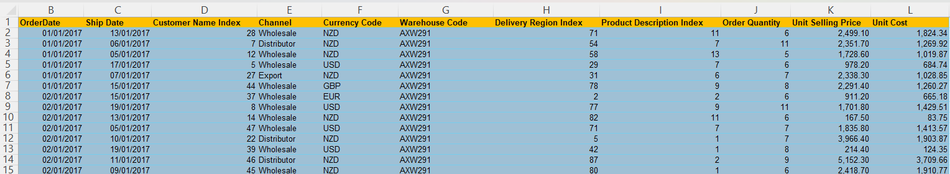

* The Customers Table contains the columns: Customer Index and Customer Name

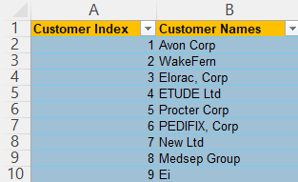

* The Regions Table contains the columns: Index, Suburb, City, postcode, Longitude, Latitude, Full Address.

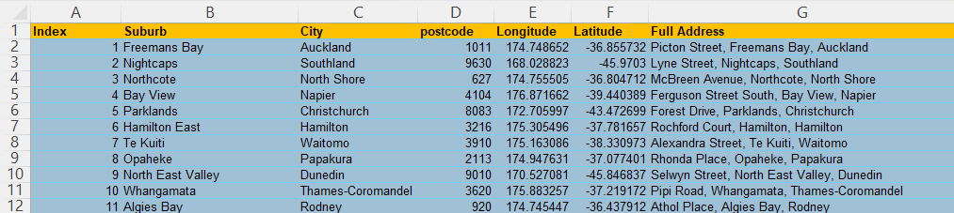

* Finally, the products table contains the Index and the Products Name.

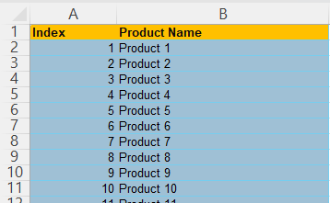

**Data Preparation:**

1. Import the Data

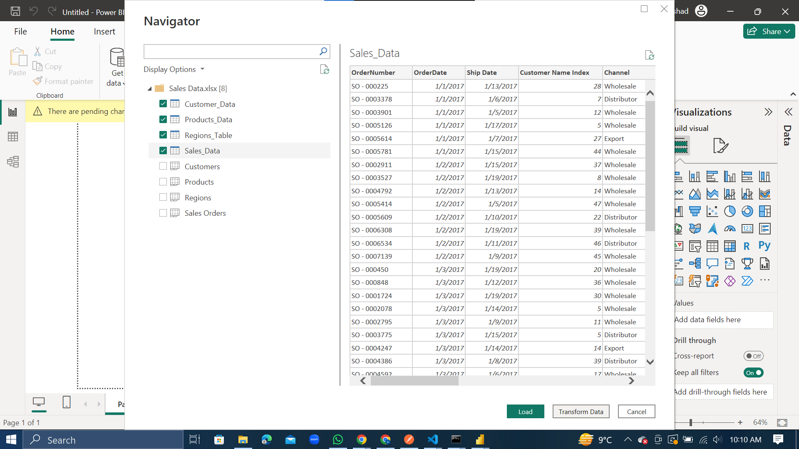

Firstly, we import the excel file and then select all the 4 sheets which are the customers data, products data, regions data and the sales data to transform it.

1. Power Query Editor

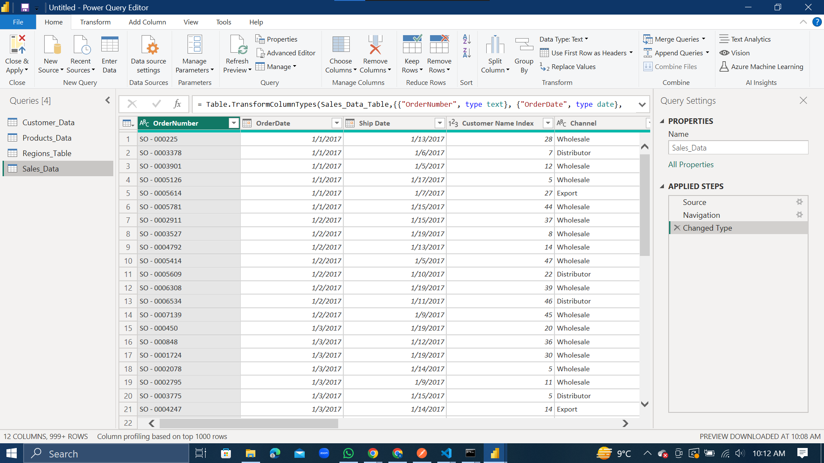

The power query editor is automatically opened after transforming the data which is now used to cleanse the data and perform initial processes on the data.

1. New Column – Sales

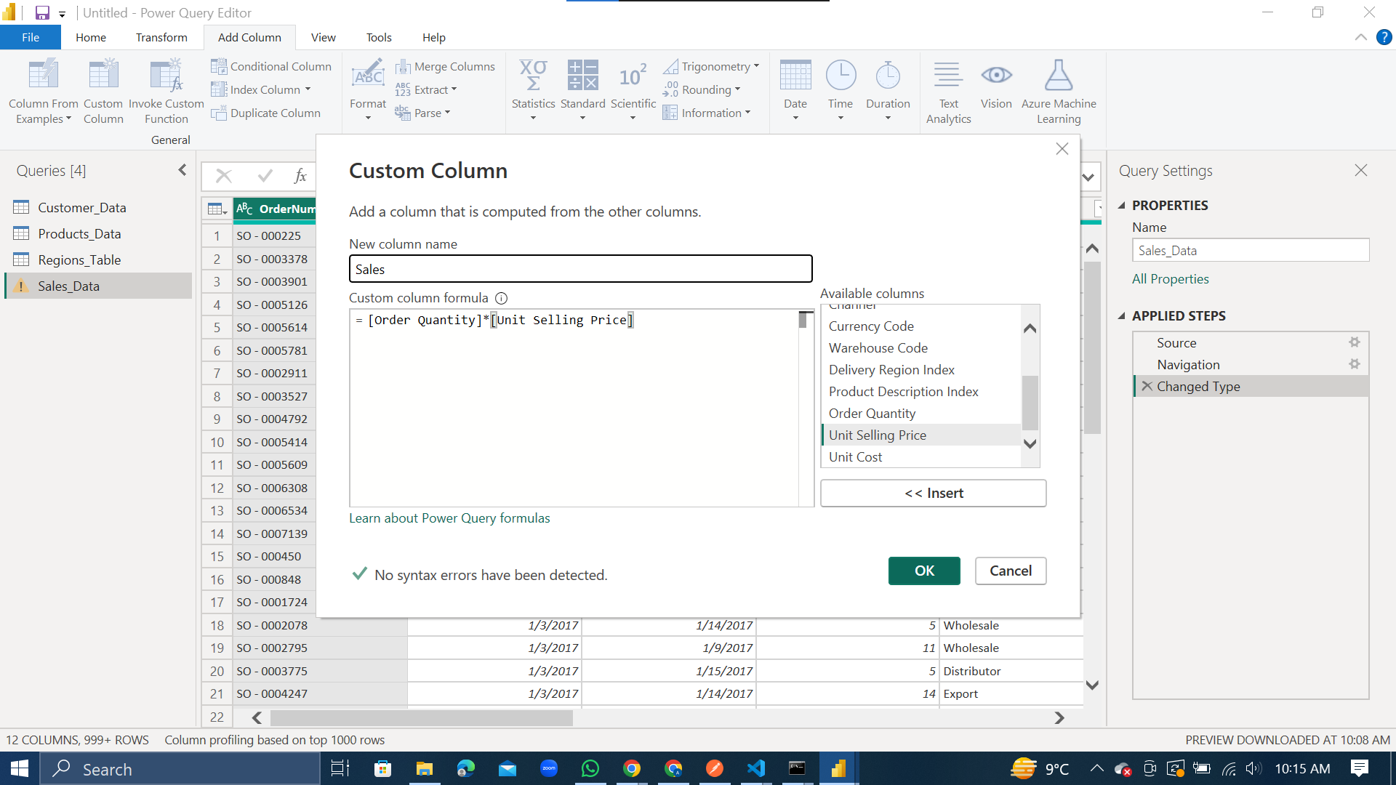

We created a new column named ‘Sales’ which is done by multiplying the Order Quantity with Unit Selling Price.

1. Change the Column Data Type

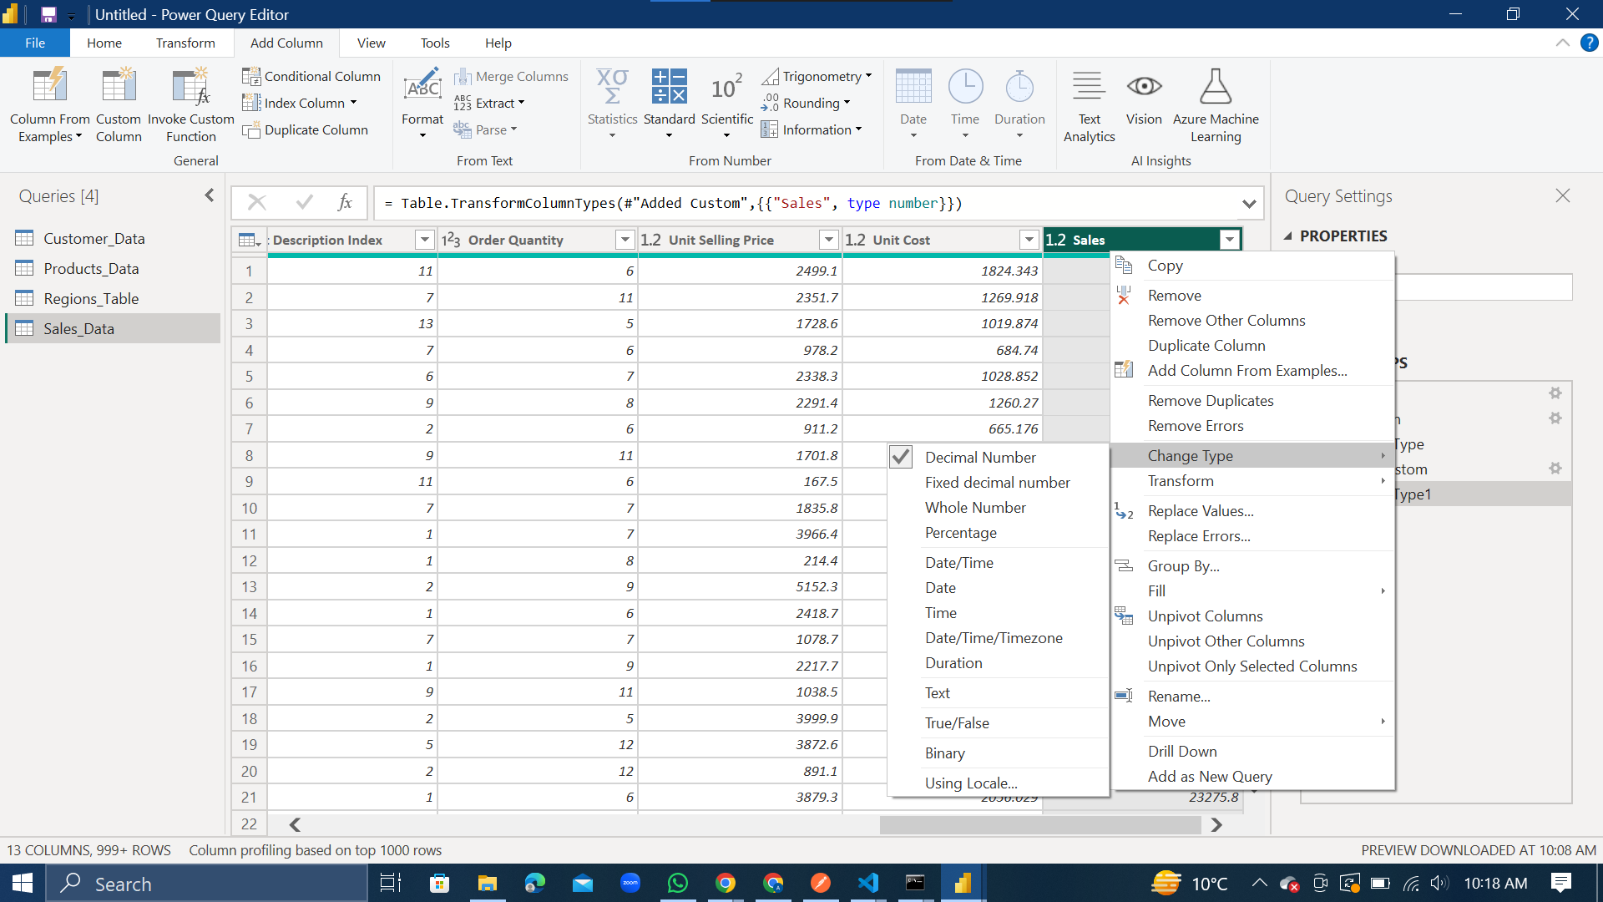

The data type of the newly created ‘Sales’ column is changed by first right clicking on the Sales column and then clicking the change type. Among the options, we select the Decimal Number for our Sales column.

1. New Column – Total Cost

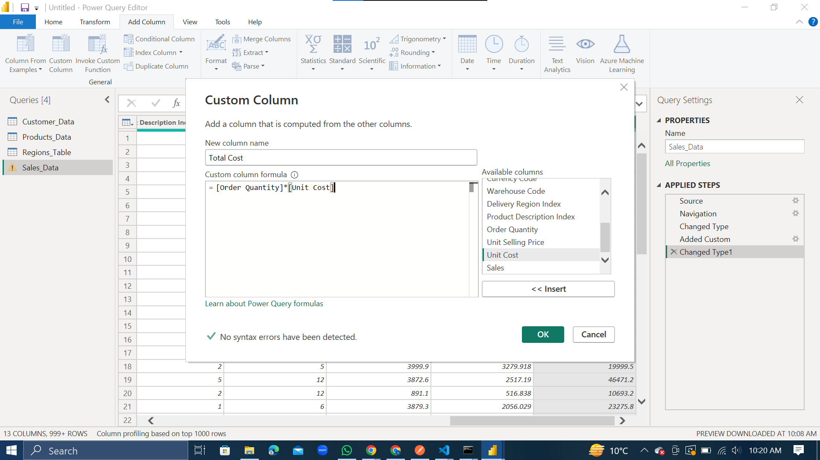

A new column is created called the ‘Total Cost’ by multiplying the Order Quantity with Unit Cost.

1. Change the Data Type of Total Cost column.

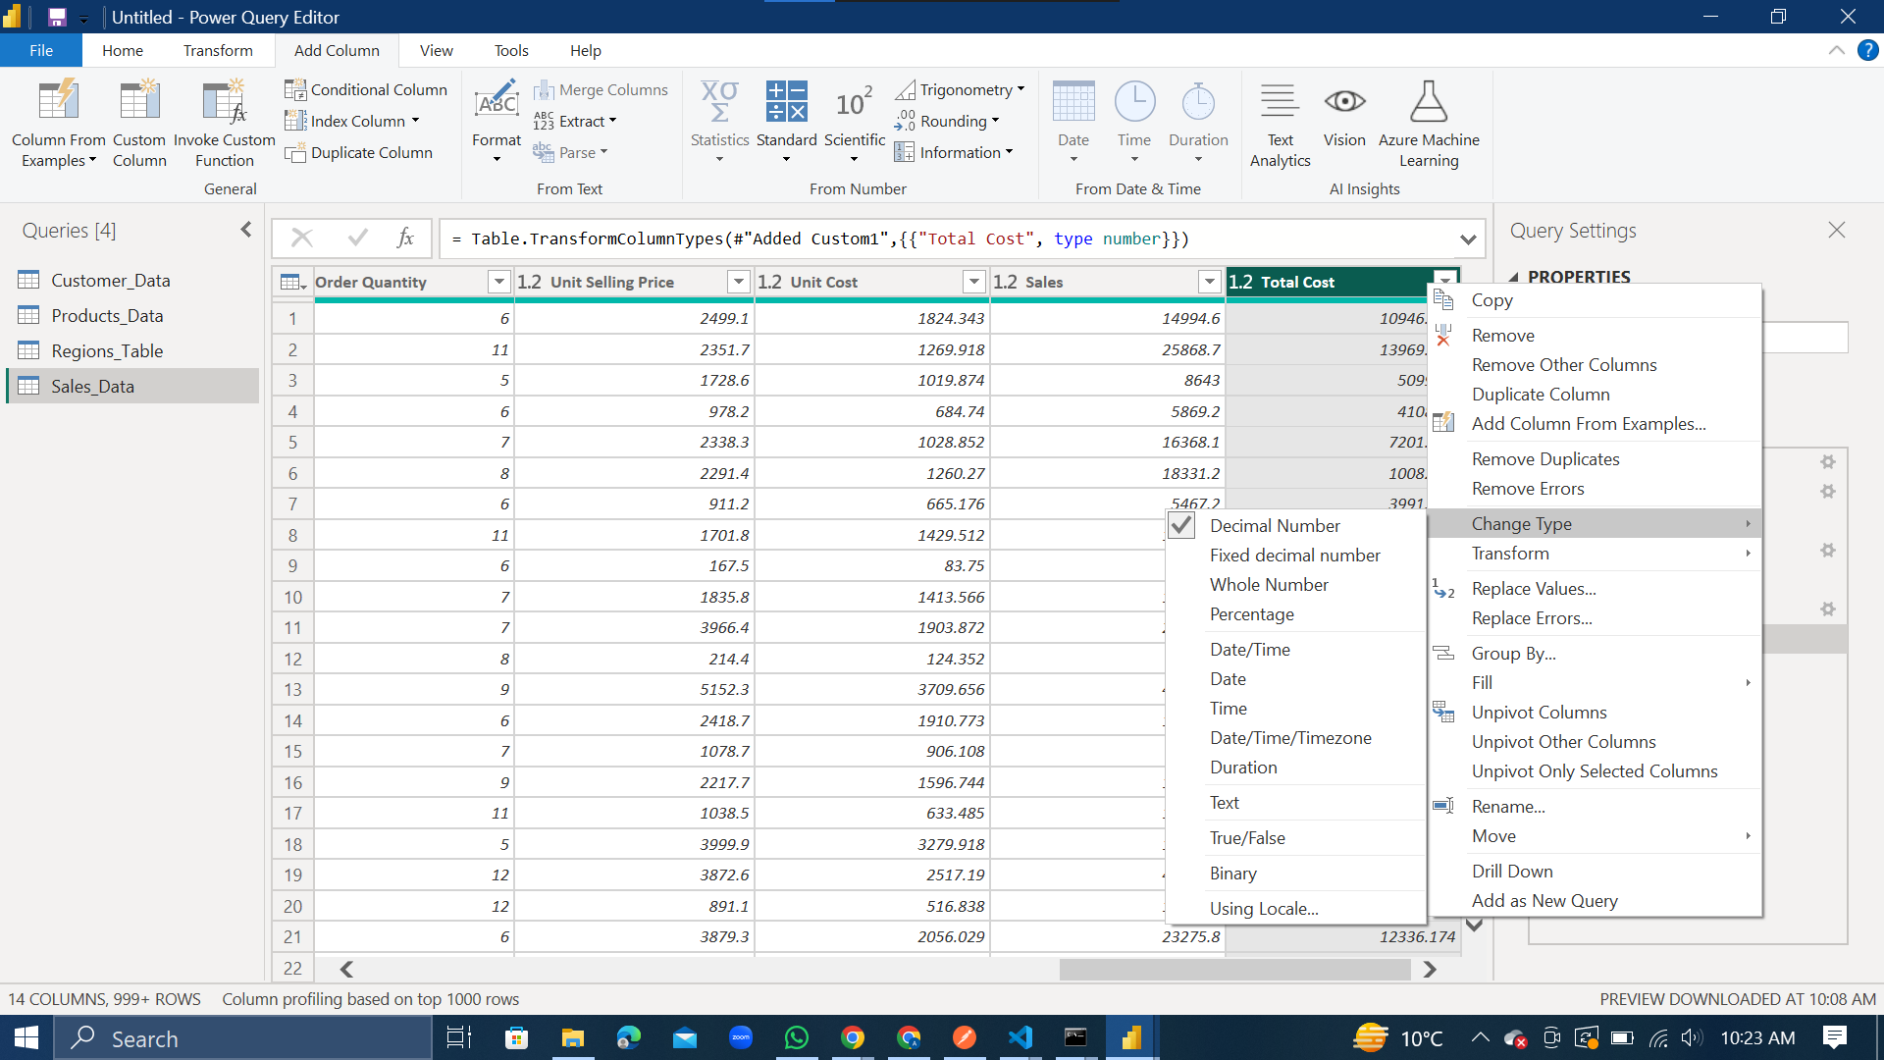

Using the same steps as in Step 4, we changed the data type of the ‘Total Cost’ column to Decimal Number.

1. Check for any errors and empty values.

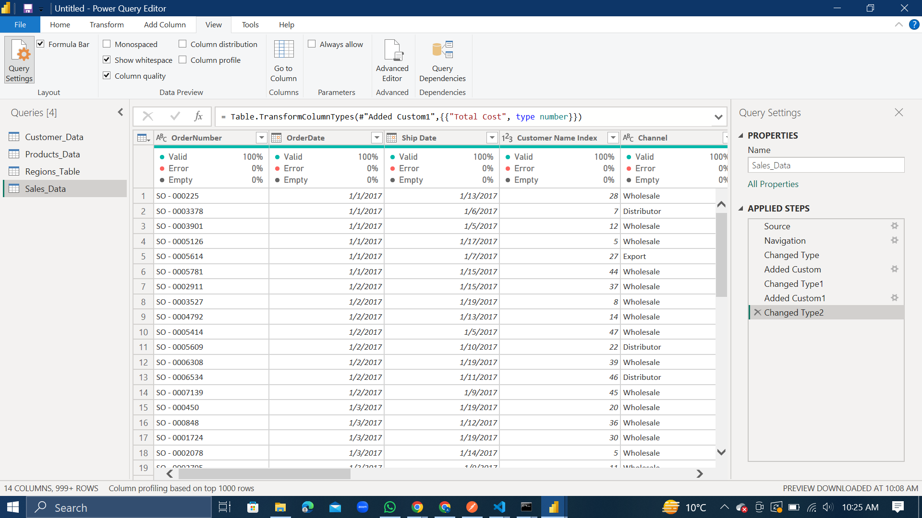

To check for any errors, empty values, and the validity of the data, we check the column quality box in the view tab. There are no errors and empty values. The data is also 100% valid.

**Power BI Desktop:**

1. Apply the changes.

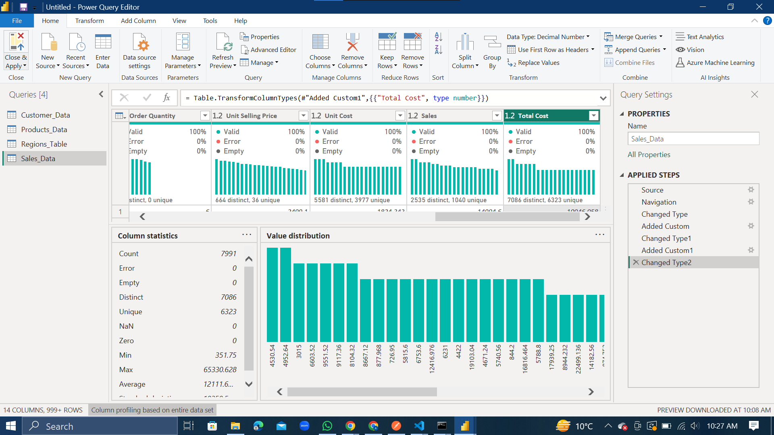

After completing the changes we intended to perform on the data (mentioned in the previous section), we close the power query editor which automatically applies all the changes on the data.

1. Recheck that the data is loaded to Power BI

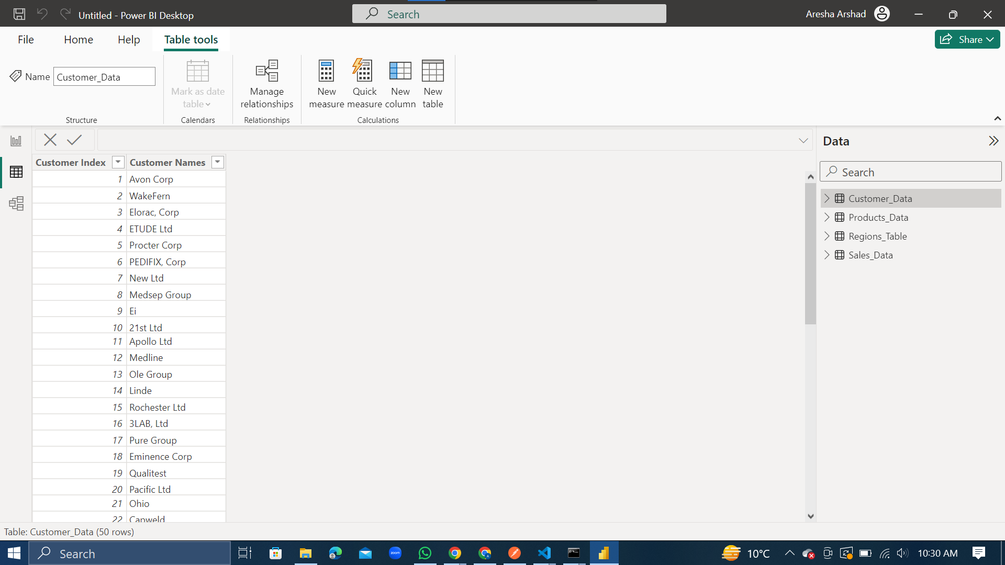

1. Create a new table – Date Table.

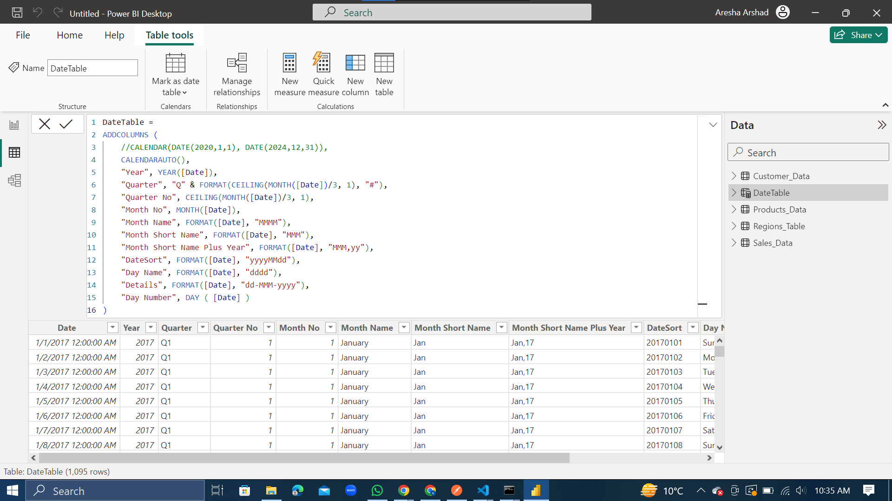

We create a new table using the DAX language. We name this table ‘Date’ as it splits the Data column to populate the new table with multiple columns (Year, Quarter, Month No etc.).

1. New Column – Month Sort

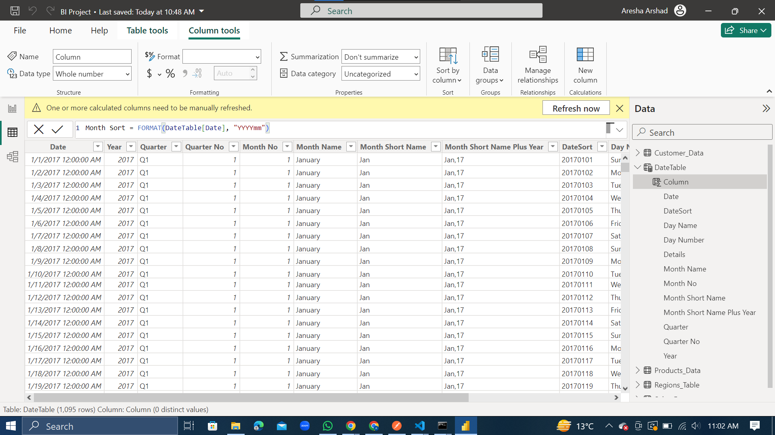

In the newly created Date Table, we created a new column called ‘Month Sort’ which sorts the months in a chronological order.

**Data Modeling:**

1. Choose of the Schema

For this dataset, we chose to use the Star Schema. The central fact table is the Sales Data and the connected dimension tables are Customer Data, Product Data, Regions Table and the Date Table. The relationship between these tables is described in the following points.

1. Sales Data and Regions Table

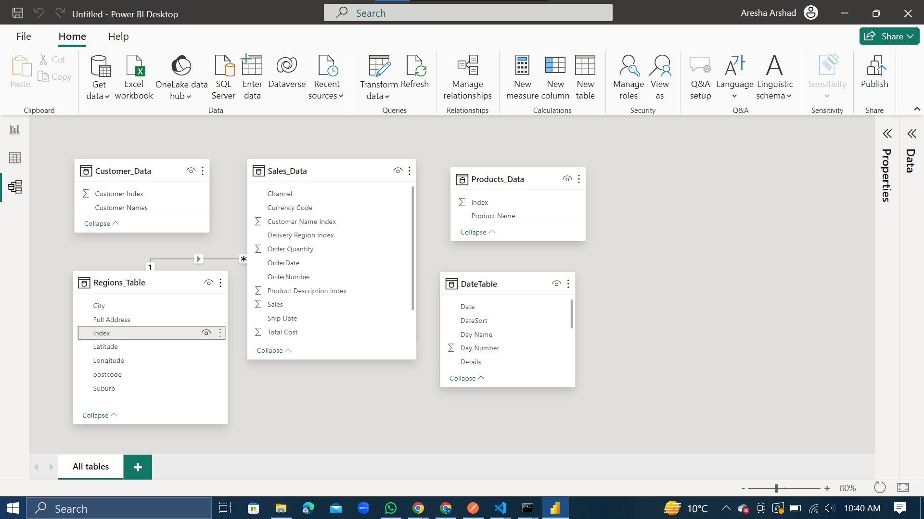

We develop a 1 to many relationship between the Delivery Region Index of the Sales Data and the Index of the Regions Table. We do this by dragging index of regions table to delivery region index of sales data table.

1. Sales Data and Customers Data

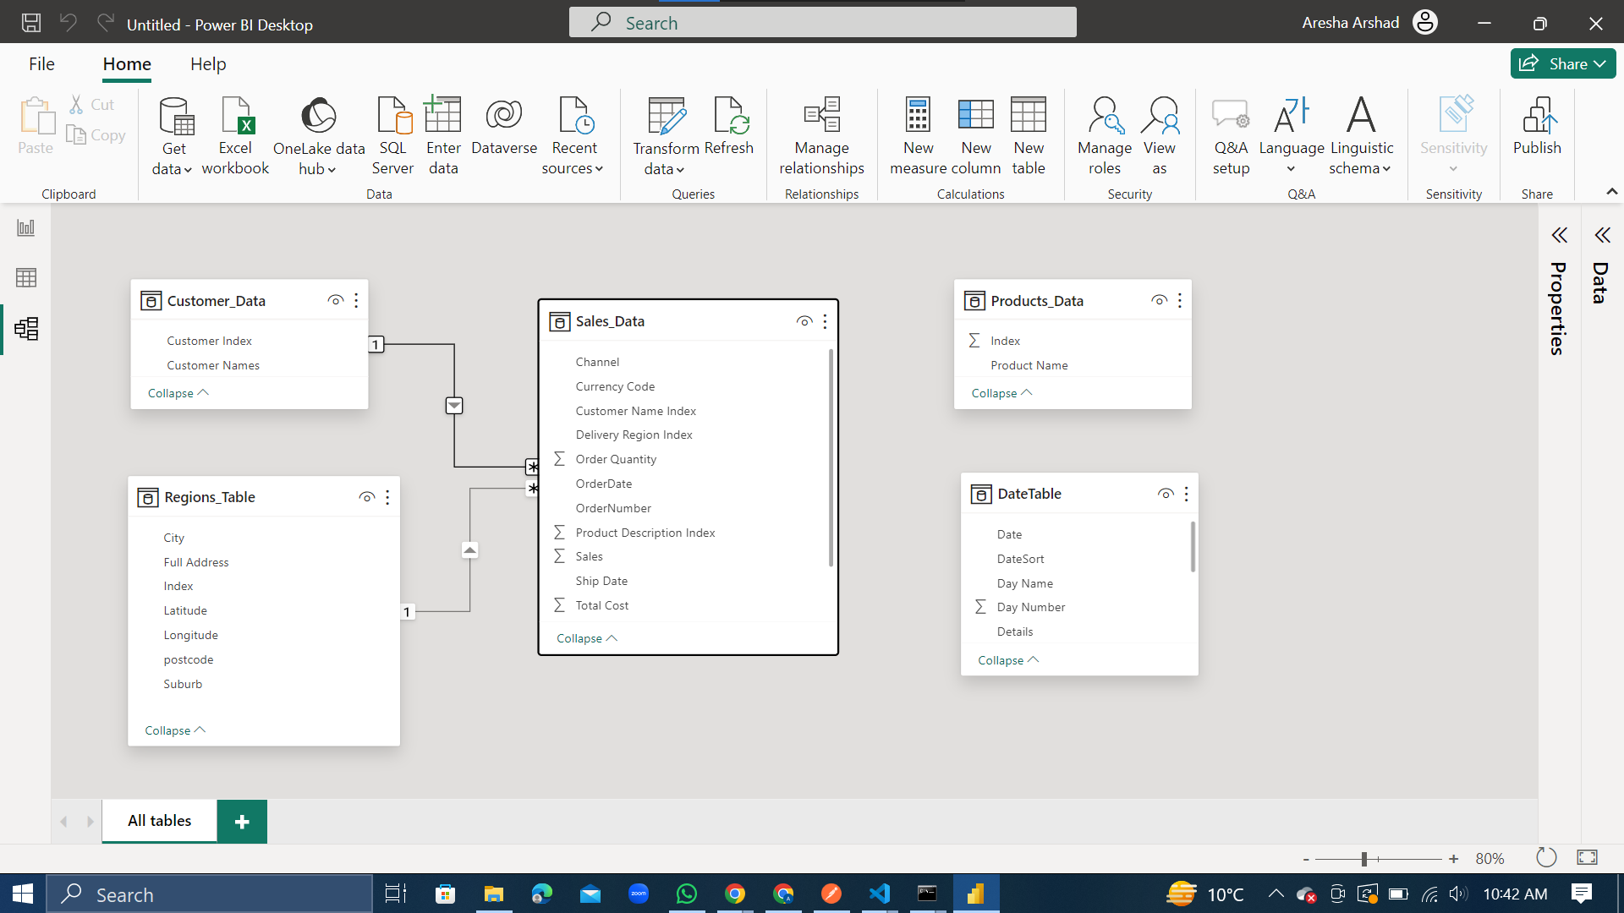

We develop a 1 to many relationship between the Customer Name Index of the Sales Data and the Customer Index of the Customers Data Table. We do this by dragging customer index of customer data table to customer name index of sales data table.

1. Sales Data Table and Products Data Table

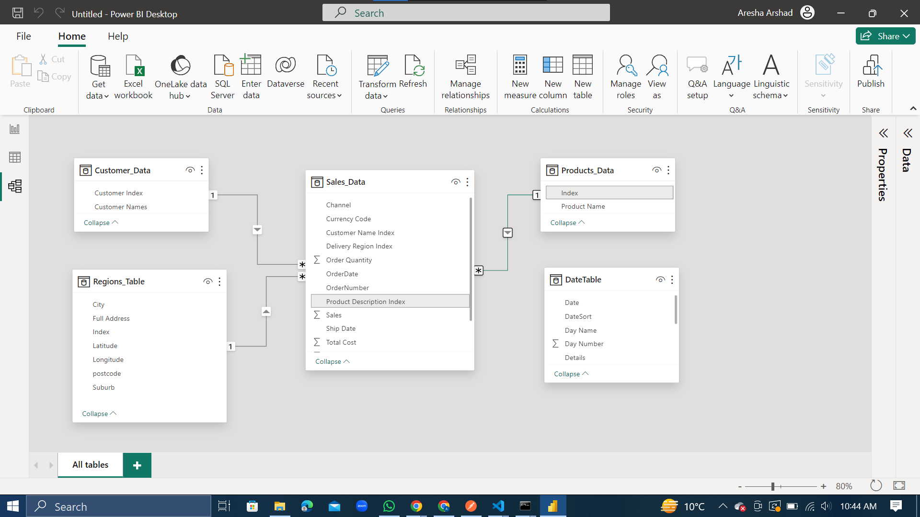

We develop a 1 to many relationship between the Product Description Index of the Sales Data and the Index of the Products Data Table. We do this by dragging index of products data table to product description index of sales data table.

1. Sales Data Table and Date Table

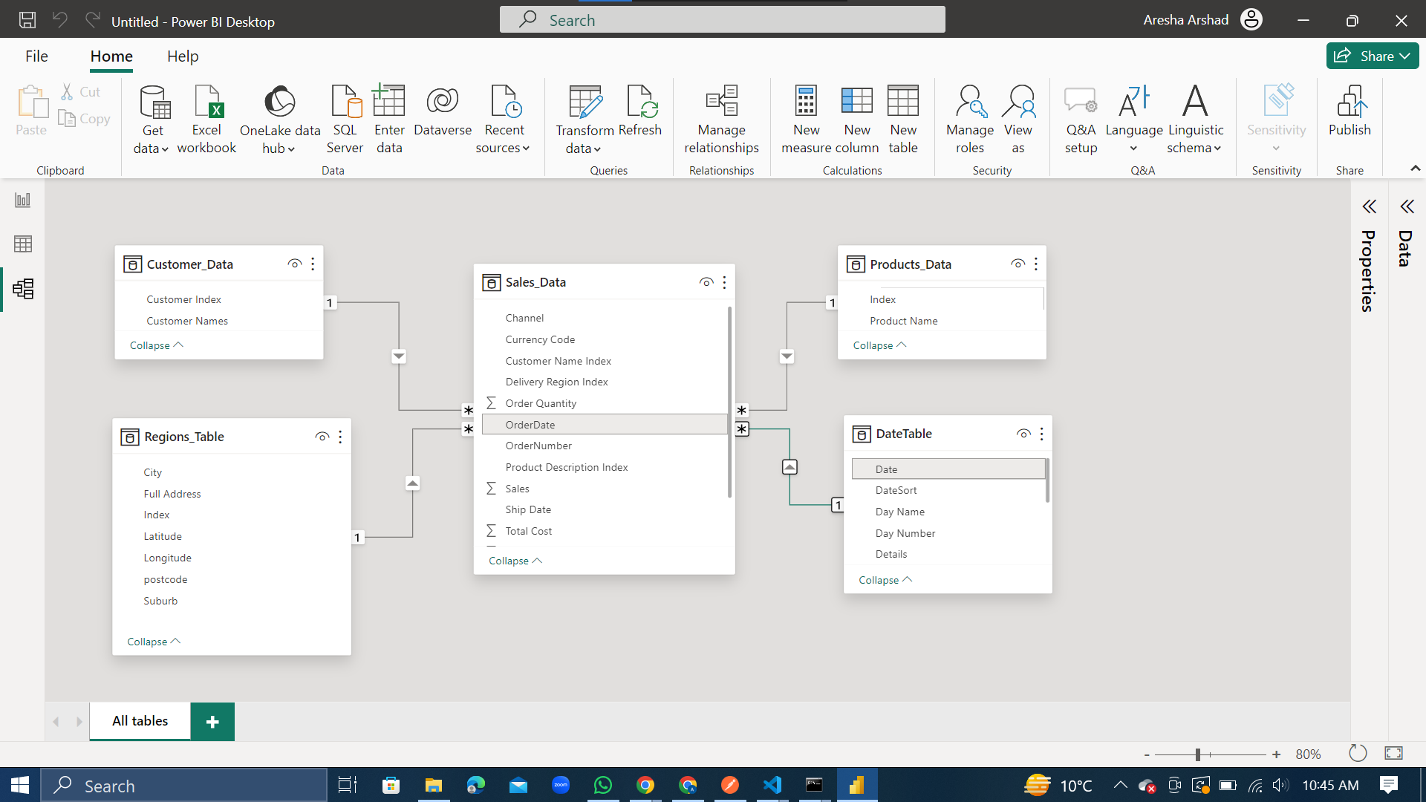

We develop a 1 to many relationship between the Order Date of the Sales Data and the Date of the Date Table. We do this by dragging the date of date table to order date of sales data table.

**Measures:**

1. New Calculate Column – Profit

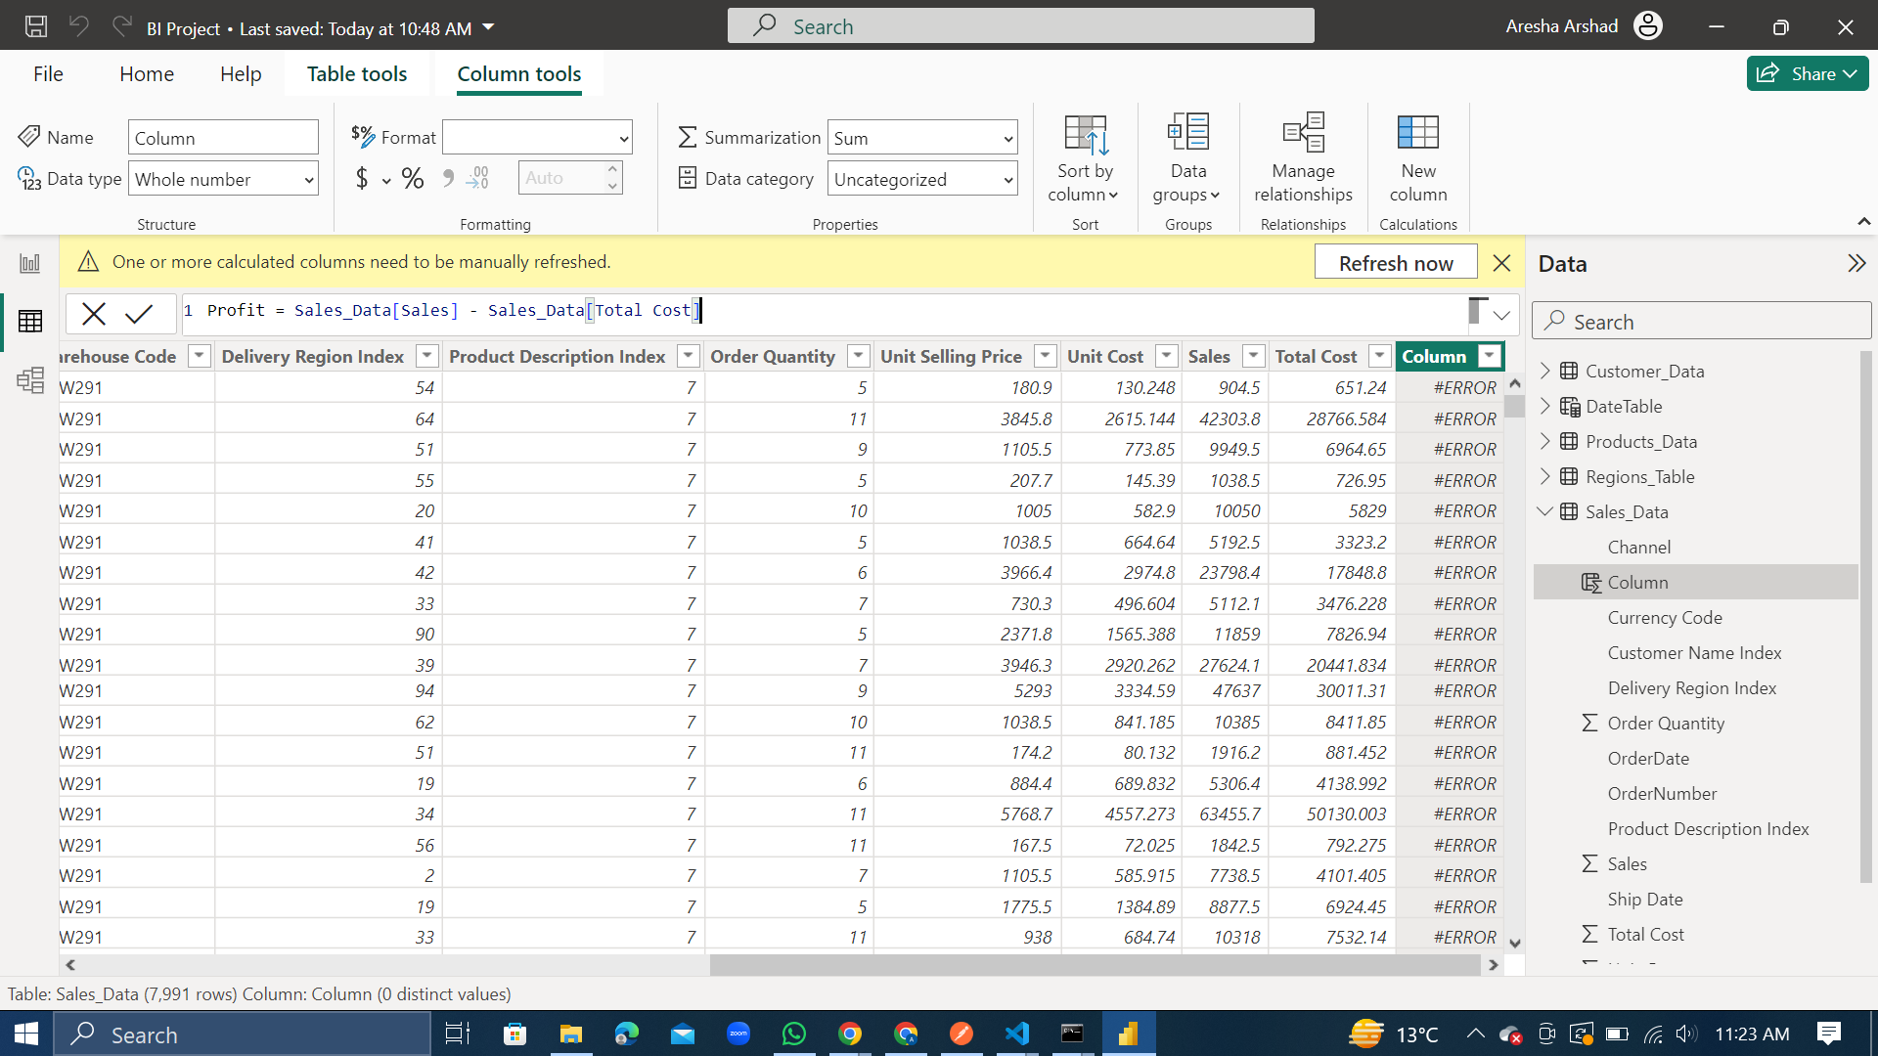

A new column is added using mathematics. Here, we create the column ‘Profit’ by subtracting the ‘Total Cost’ of the Sales Data Table from the ‘Sales’ of the Sales Data Table.

1. New Measure Table

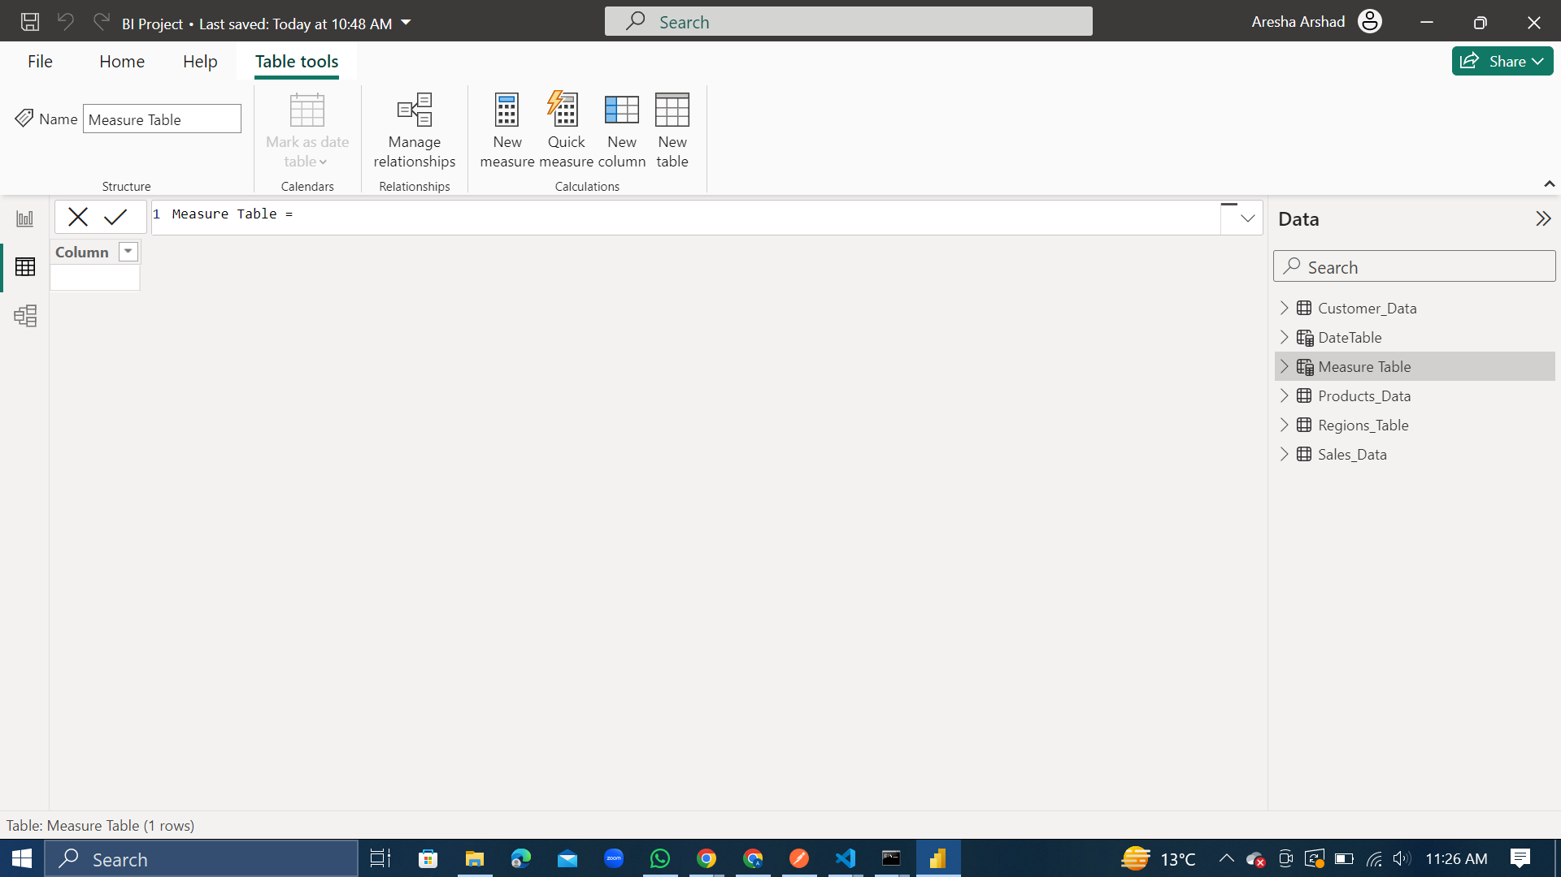

We then proceeded to create a new Measure Table that will contain all the measured quantities used for DAX. These measured quantities will be calculated in the following points. Each by first right clicking on the Measure Table.

1. Measure 1 – Sales

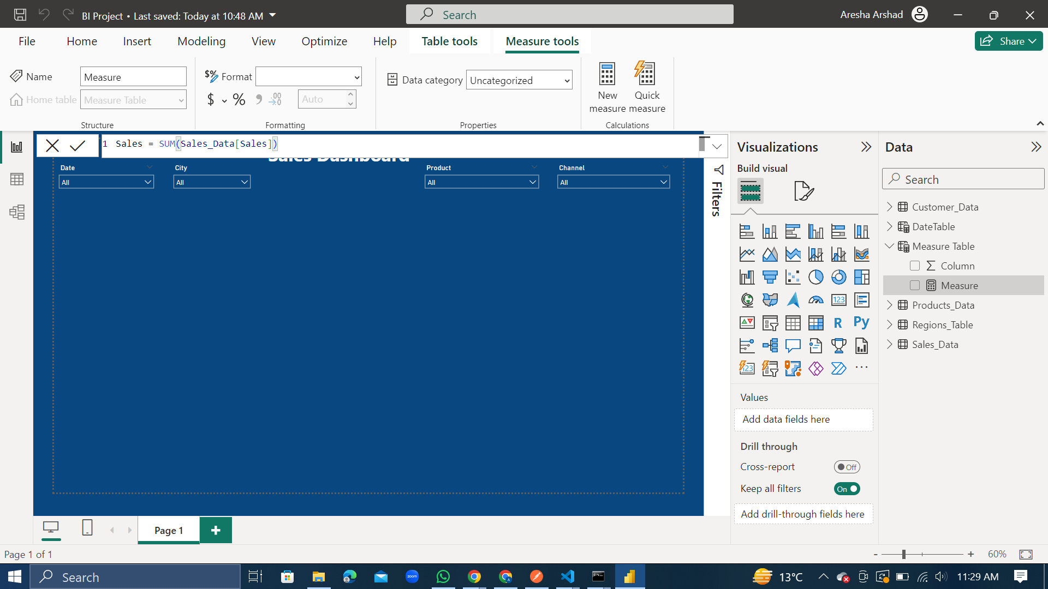

We calculated the measure ‘Sales’ by using the above formula. Sales is the sum of all the sales in the sales data table.

1. Measure 2 – Sales PY

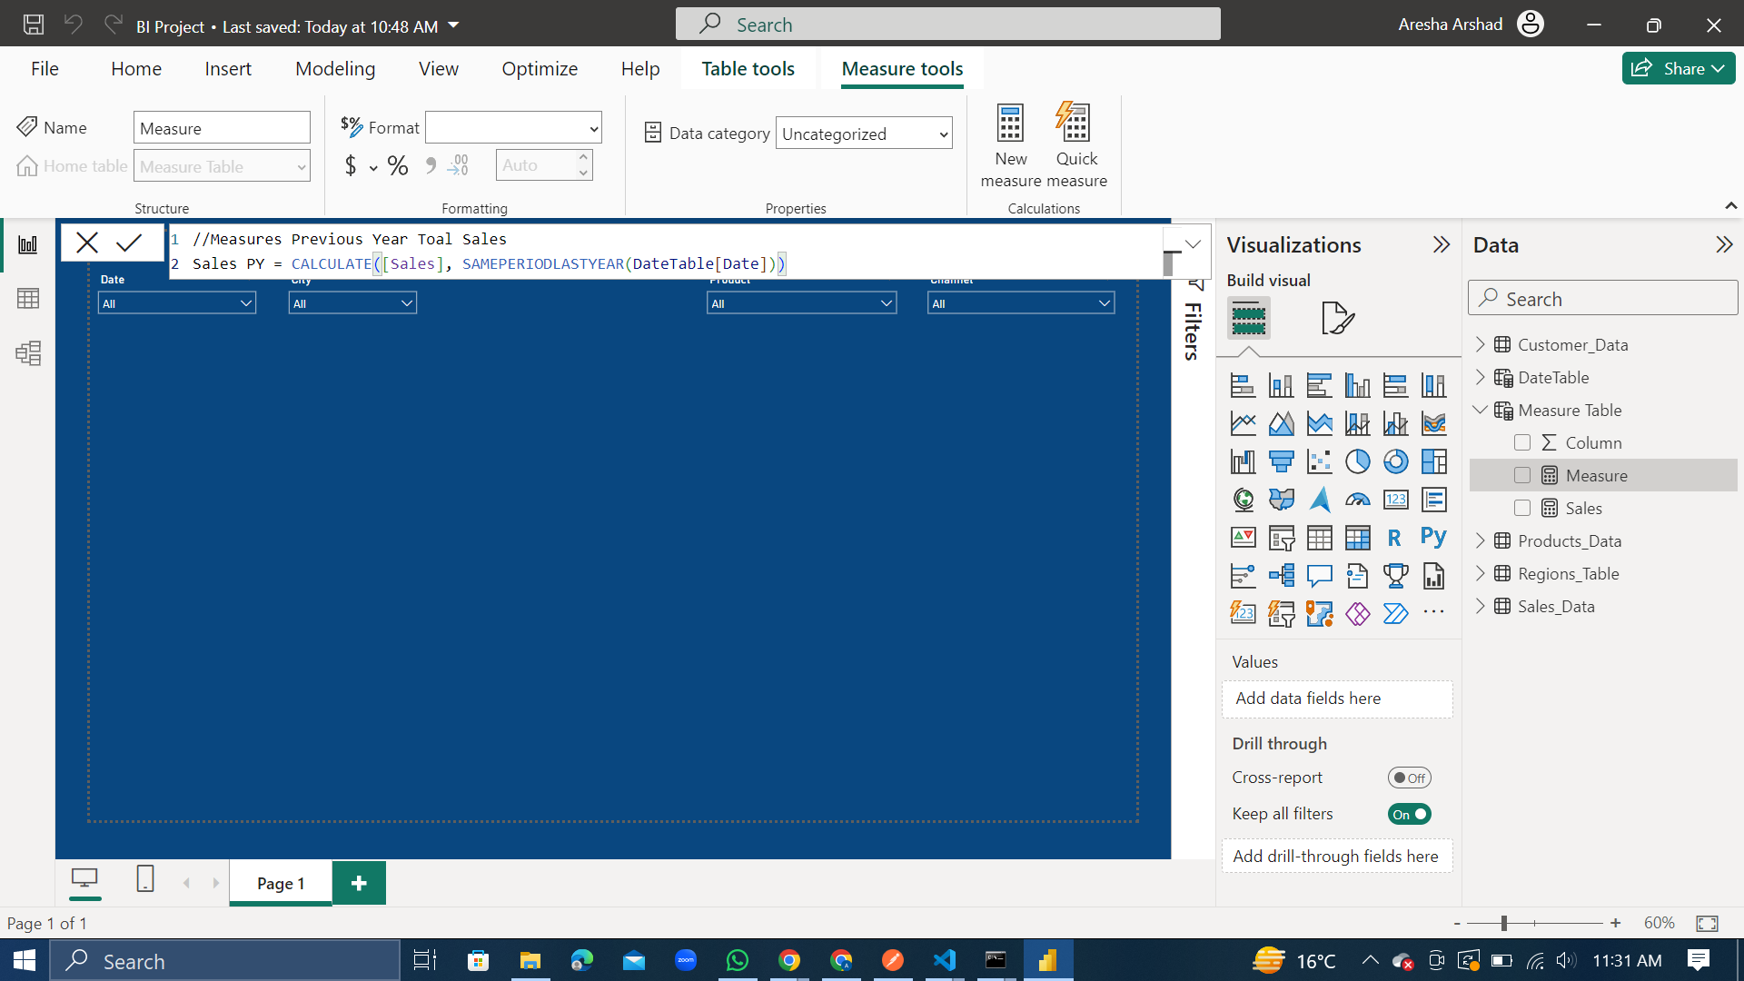

We calculated the measure ‘Sales PY’ by using the above formula. Sales PY is total sales for the previous year.

1. Measure 3 – Sales vs PY

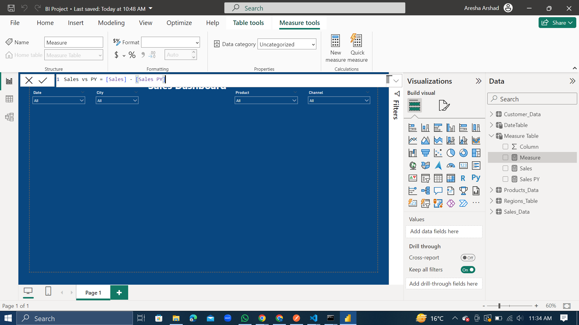

We calculated the measure ‘Sales vs PY’ by using the above formula. Sales vs PY is the difference between the current year’s Sales and previous year’s Sales.

1. Measure 4 - Sales vs PY %

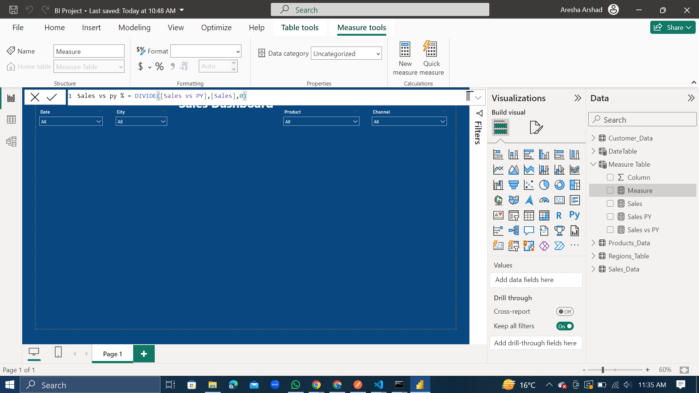

We calculated the measure ‘Sales vs PY %’ by using the above formula. Sales vs PY % is the percentage increase/decrease in the Sales year on year (YOY%).

1. Measure 5 – Products Sold

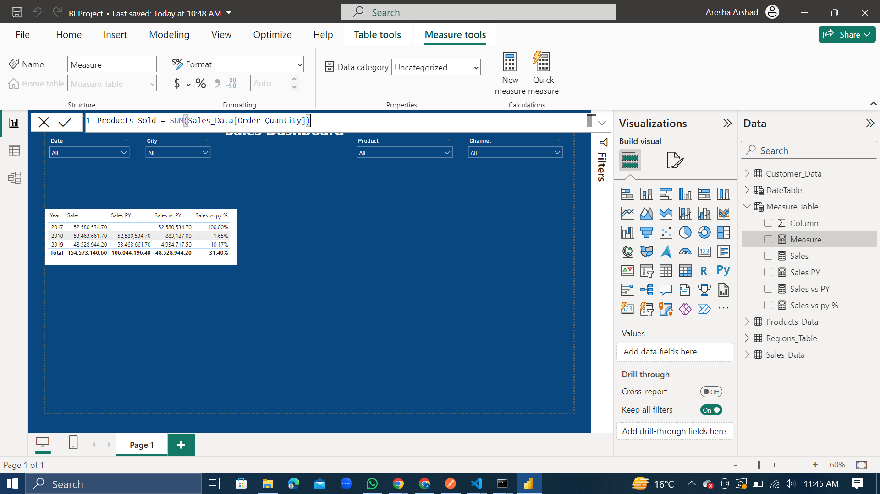

We calculated the measure ‘Products Sold’ by using the above formula. Products Sold is the total number of products sold.

1. Measure 6 – Profit

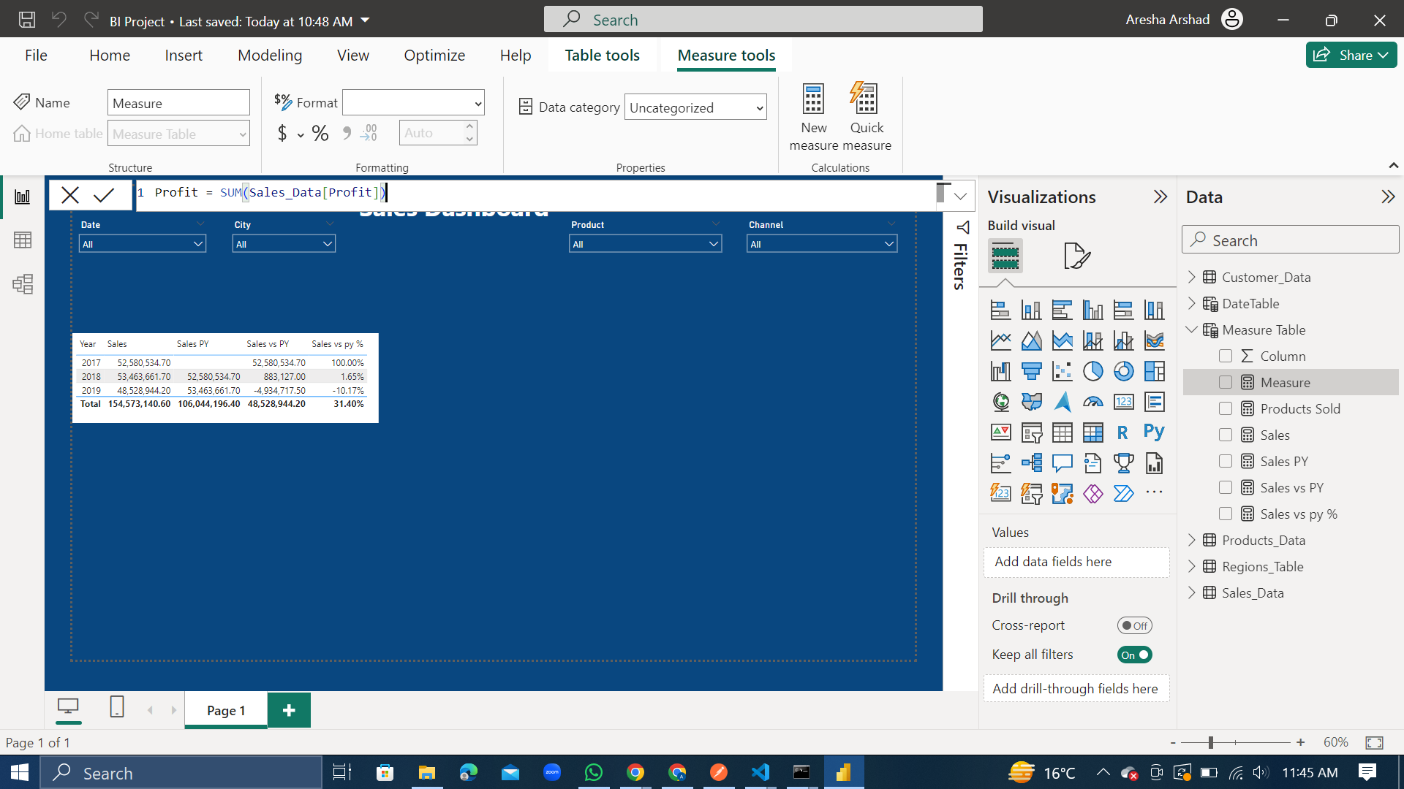

We calculated the measure ‘Profit’ by using the above formula. Profit is the sum of profits.

1. Measure 7 – Proft LY

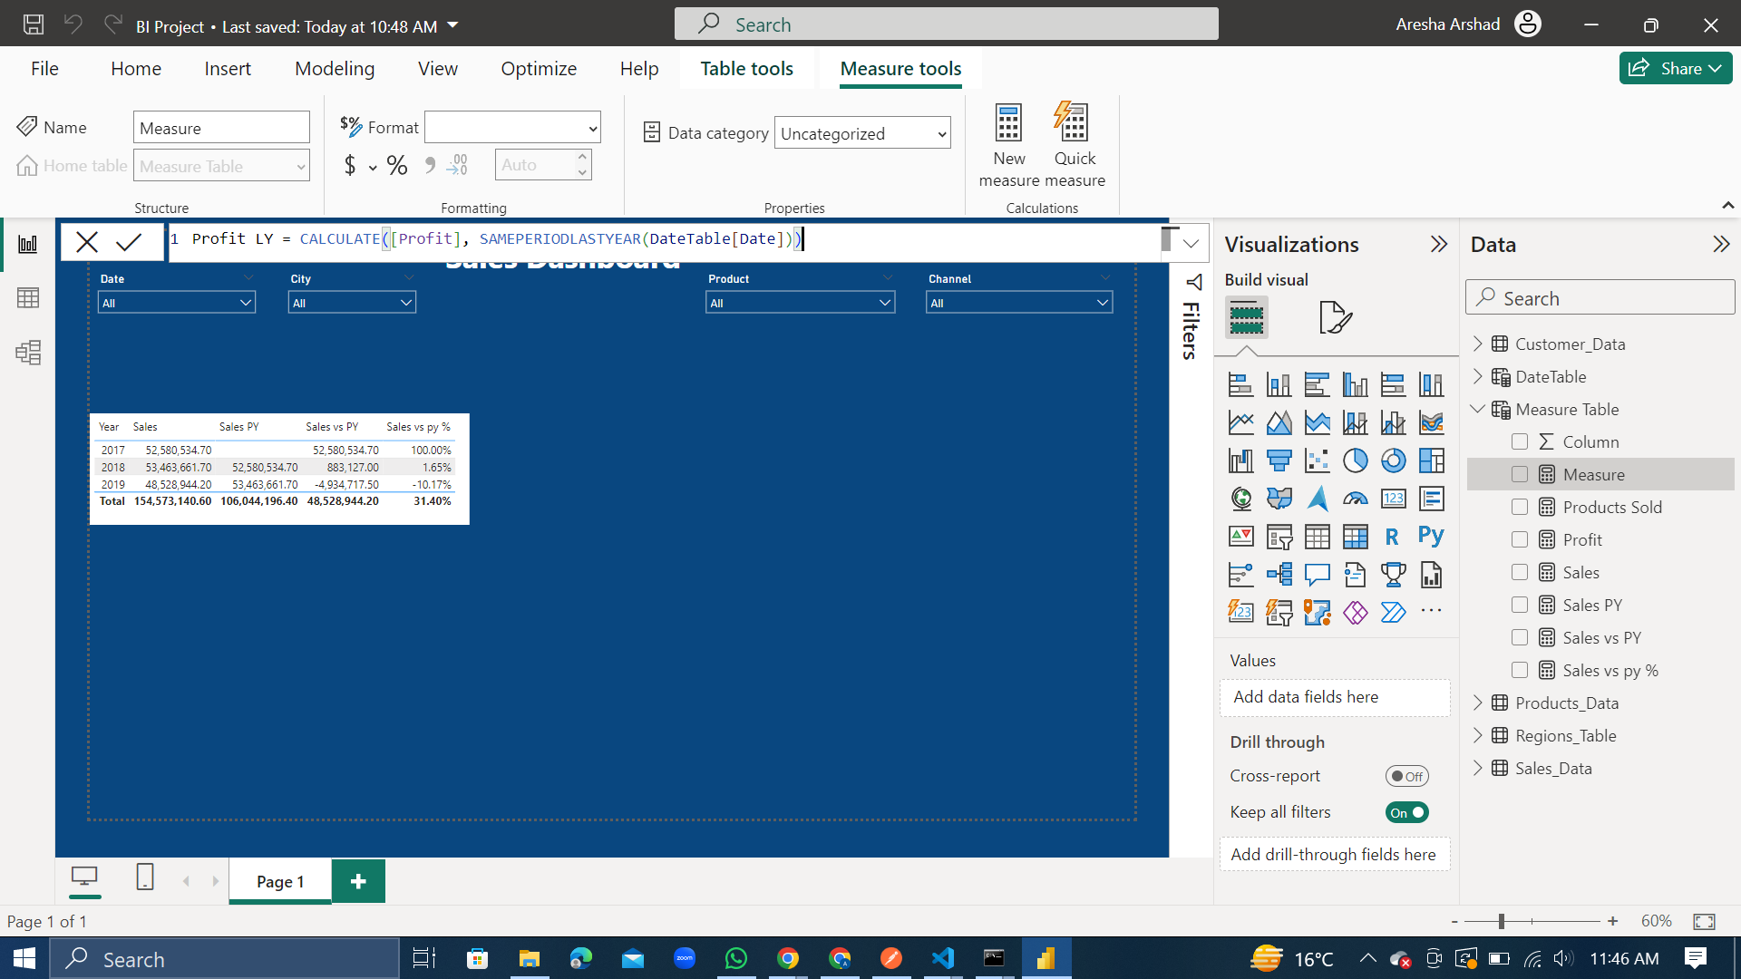

We calculated the measure ‘Profit LY’ by using the above formula. Profit LY is the profit of Last Year.

1. Measure 8 – Profit vs LY

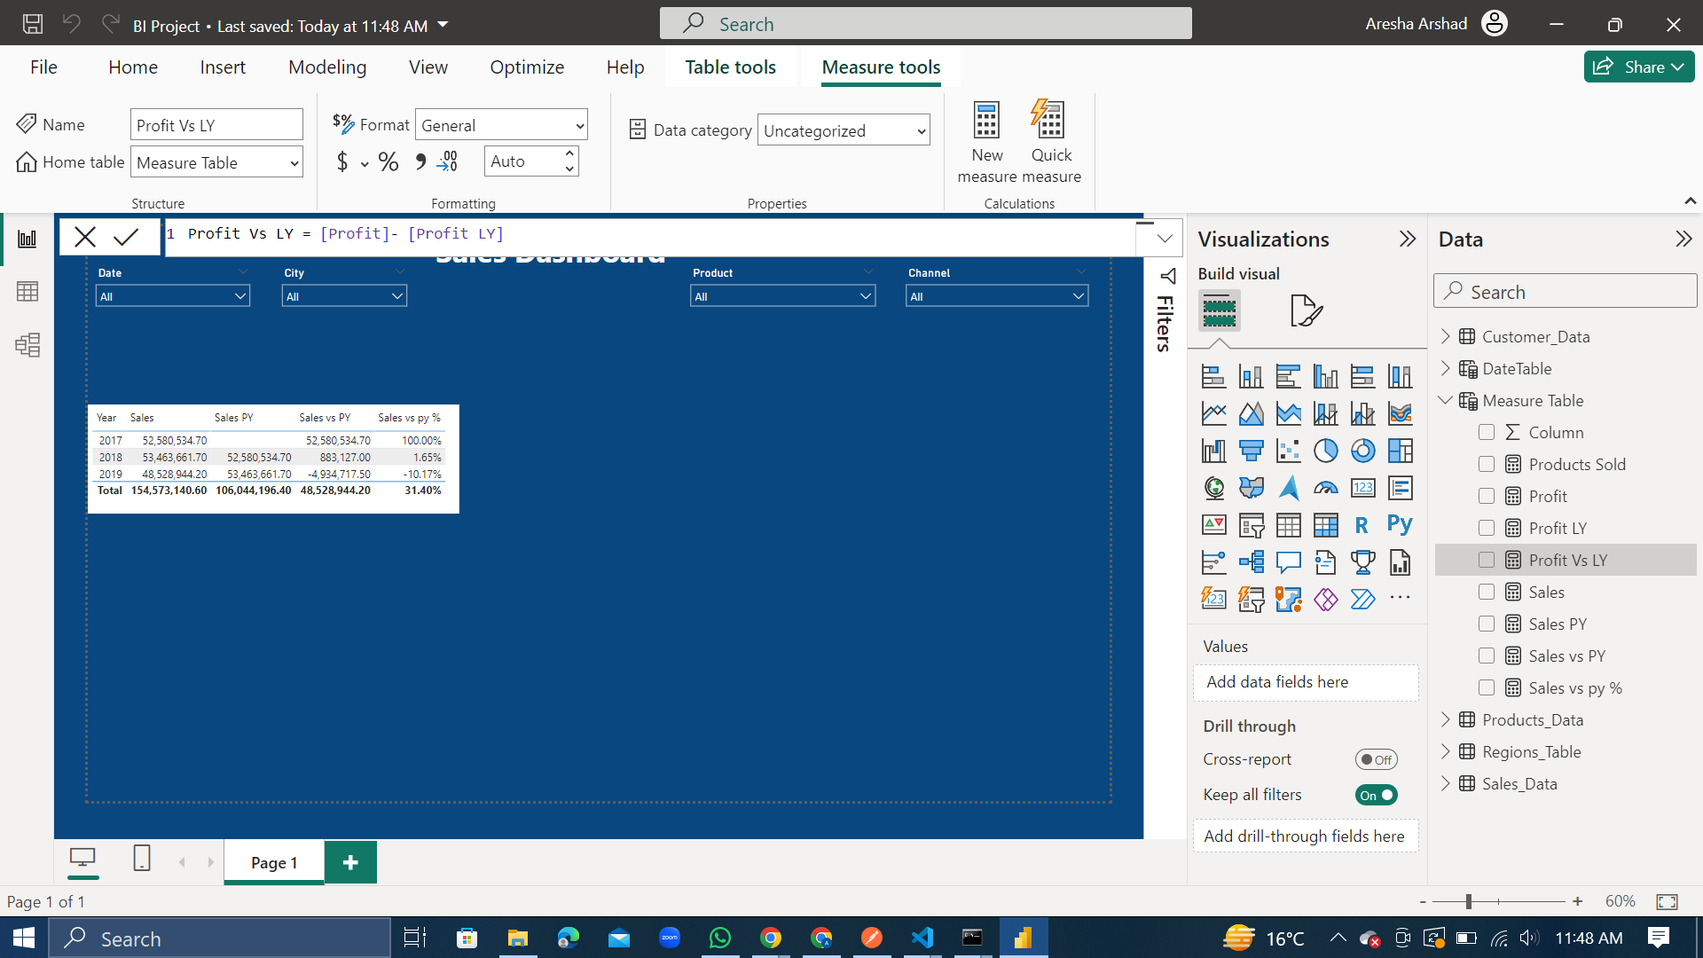

We calculated the measure ‘Profit vs LY’ by using the above formula. Profit vs LY is the difference between the total profit and the profit of Last Year.

1. Measure 9 – Profit vs LY %

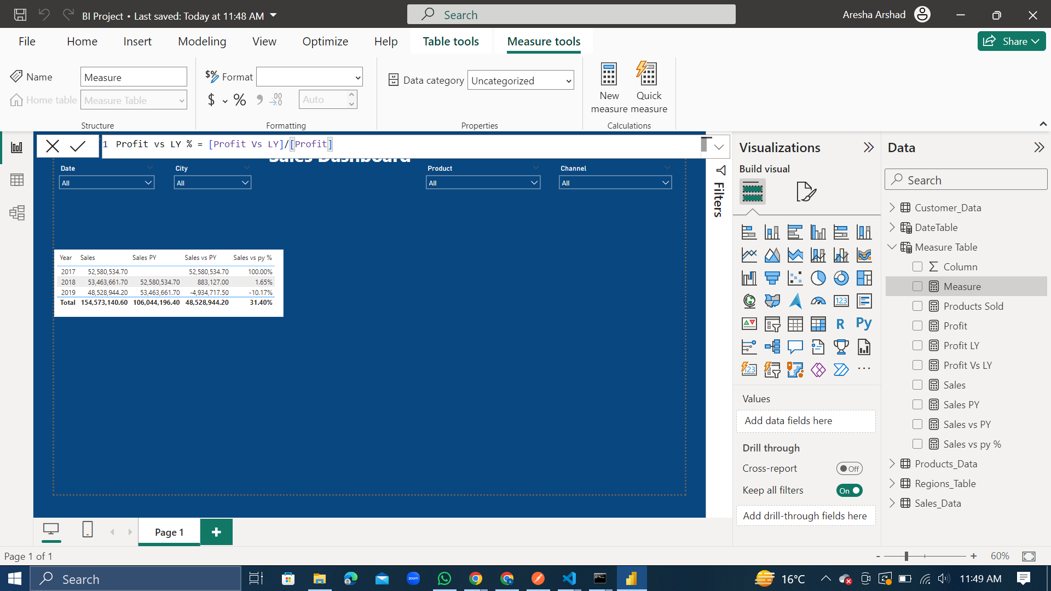

We calculated the measure ‘Profit vs LY %’ by using the above formula. Profit vs LY is the percentage of the profit of Last Year from the total Profit.

1. Measure 10 – Profit Margin

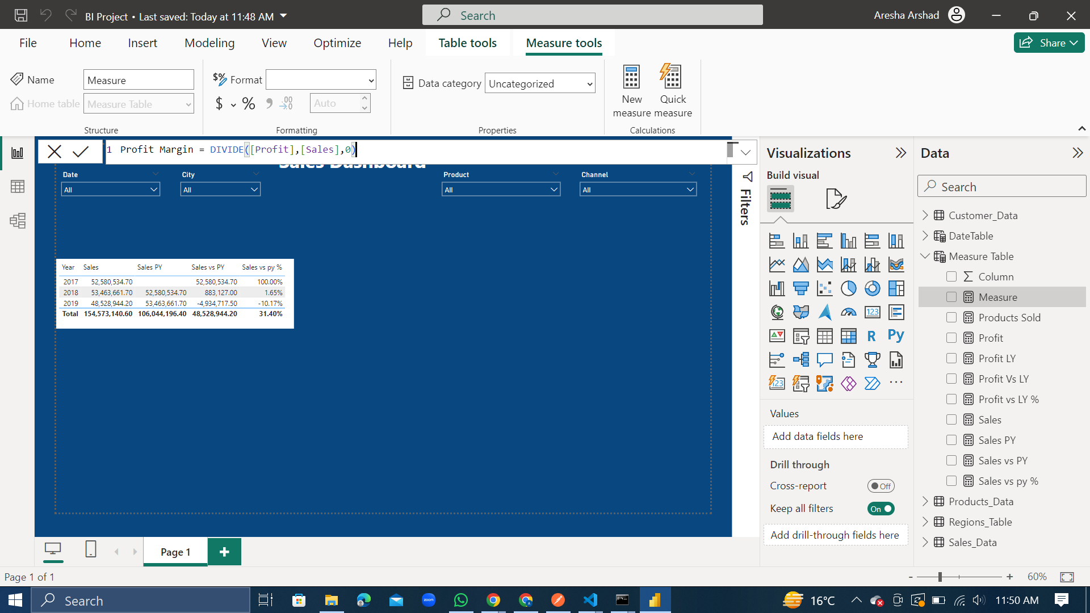

We calculated the measure ‘Profit Margin’ by using the above formula. Profit Margin is the ratio of Profit and Sales.

1. New Measure 11 – Total Cost

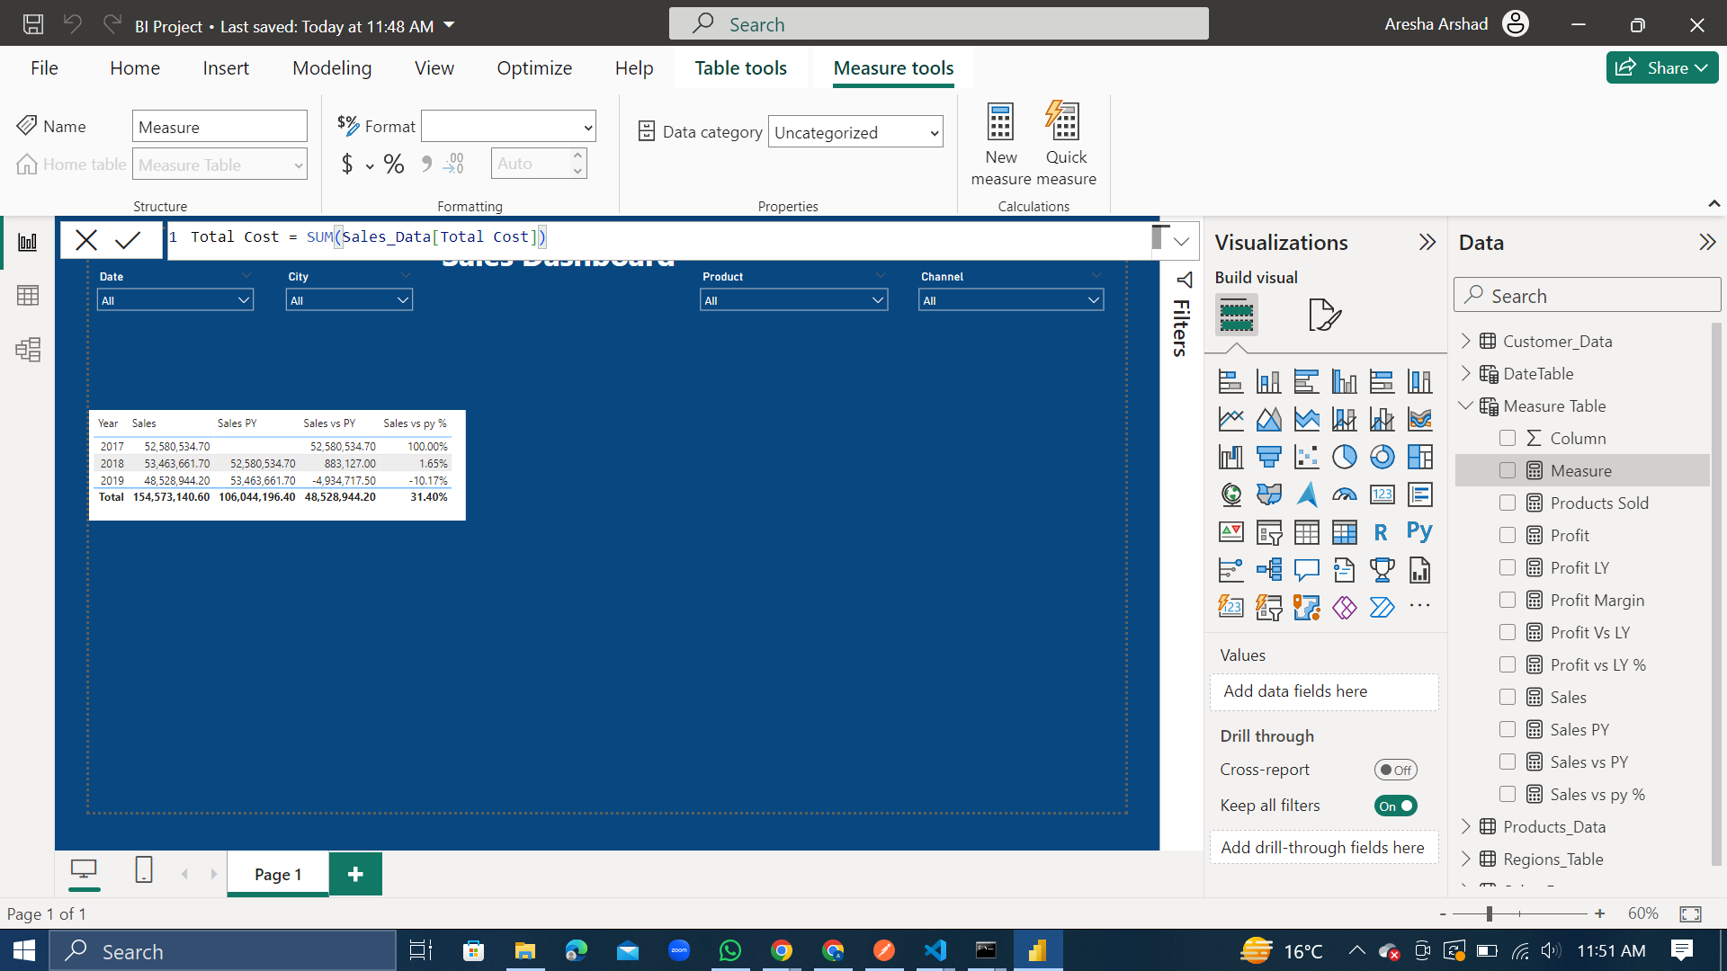

We calculated the measure ‘Total Cost’ by using the above formula. Total Cost is the sum of all costs.

**Interactivity:**

1. Slicers

We created 4 kinds of slicers for this data, namely: Date, City, Product and Channel.

* Sales

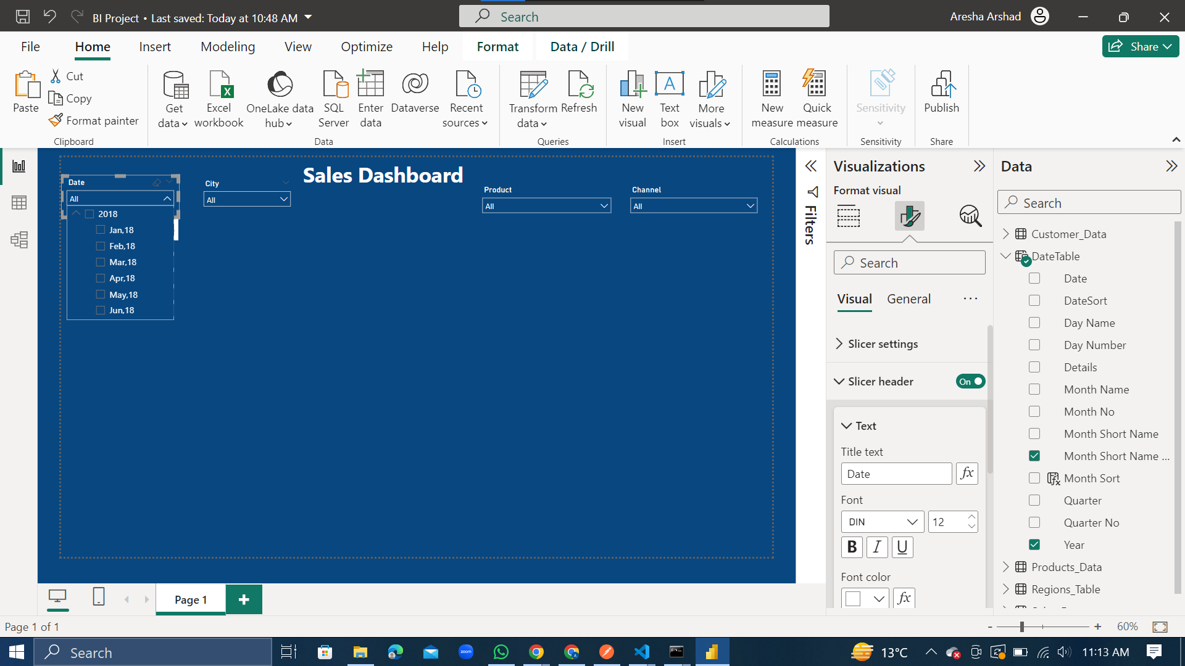

* City

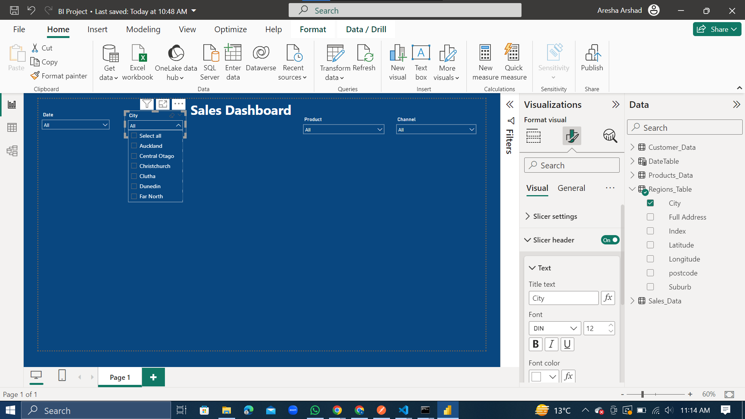

* Product

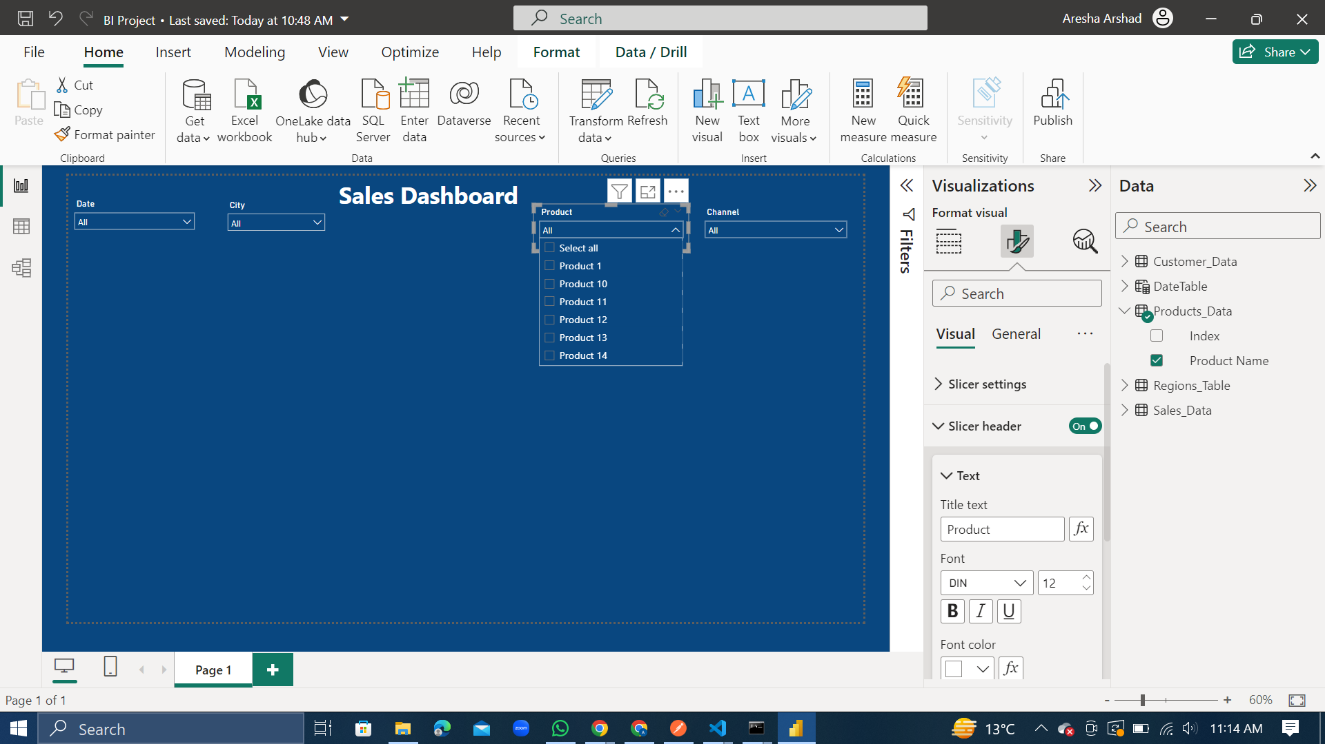

* Channel

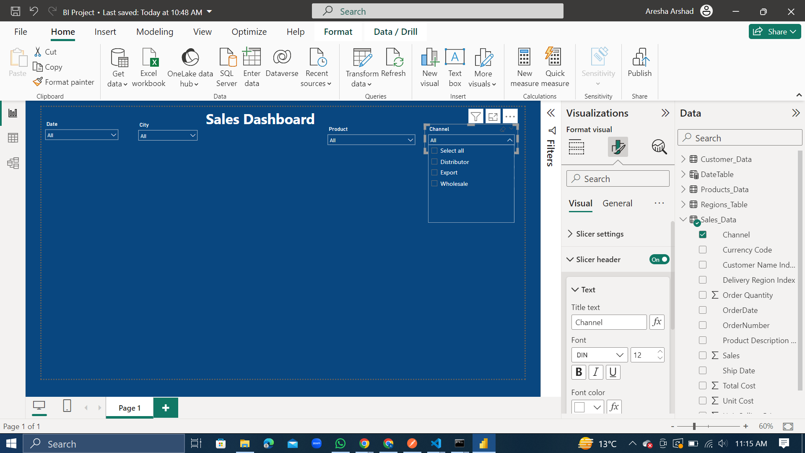

**Visualizations:**

1. Total Sales and Previous Year Sales per Product

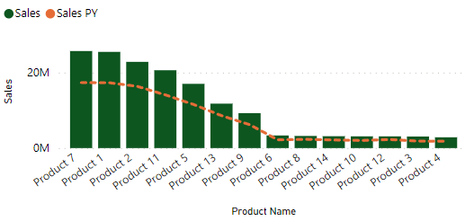

The following conclusions can be derived from the above graph:

* ﻿﻿At 25M, Product 7 had the highest Sales and was 799.81% higher than Product 4, which had the lowest Sales at 2M.﻿
* ﻿Product 7 accounted for 16.63% of Sales.﻿
* ﻿Sales and Sales PY are positively correlated with each other.﻿
* ﻿Second highest sales are of Product 1 which is not much lower than Product 7.
* Products 6,8,14,10,12,3 and, 4 produce the least number of sales.

1. Total Sales and Previous Year Sales per Month

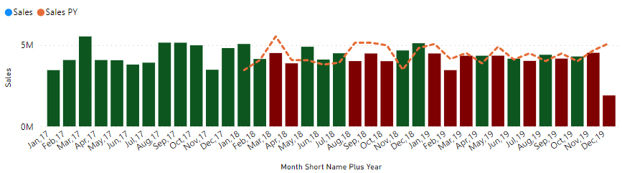

To generate this graph, the following conditional formatting was applied:

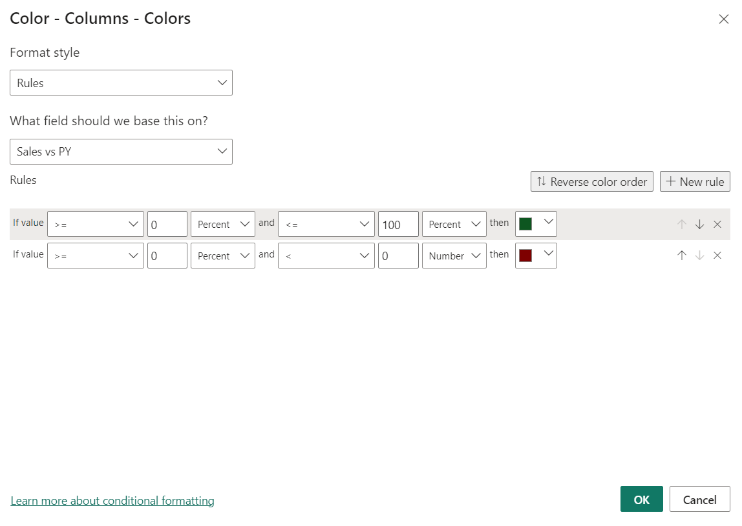

The insights gathered from this graph are:

* The highest sales (5M) are in March 2017 which were 190.2% higher than that of December 2019, which had the lowest Sales (1M).﻿﻿
* ﻿﻿Mar 2017 accounted for 3.58% of Sales.﻿﻿
* ﻿﻿Sales and total Sales PY are positively correlated with each other.﻿﻿
* ﻿﻿Sales PY and Sales diverged the most when in December 2019, when Sales PY were 3M higher than Total Sales.﻿﻿
* The Sales of the Previous Year are higher in the March, April, August, September, and October of 2018 along with January, February, March, May, July, September, November and December of 2019.

1. Sales by City

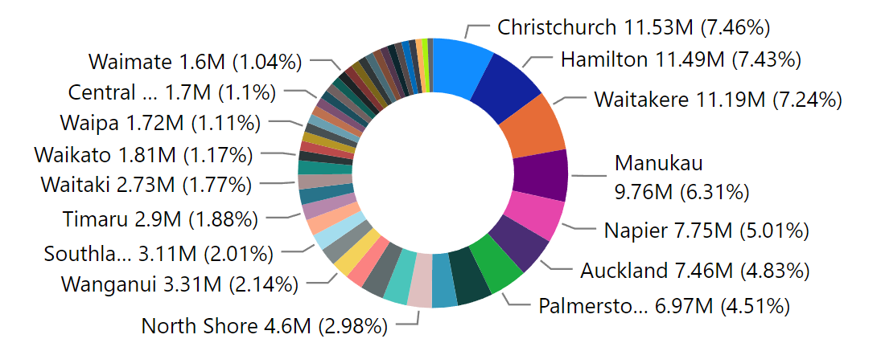

* Many cities have less than 1.5% share in the sales.

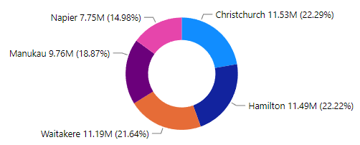

The top 5 cities with the highest sales are considered in the pie chart.

* Christchurch, Hamilton and Waitakere are the cities with the highest sales (almost 22% for each).

1. Total Profit, Profit Last Year, and Profit Margin per Channel

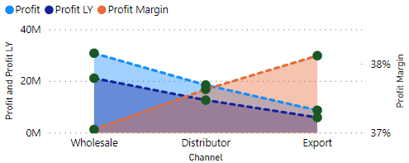

This graph shows:

* ﻿At around 30M, Wholesale had the highest Profit and was 256.20% higher than Export, which had the lowest Profit at around 8M.﻿﻿
* ﻿﻿Profit and Profit LY are positively correlated with each other.﻿﻿
* ﻿﻿Wholesale accounted for 53.18% of Profit.﻿﻿
* Distributor and Export combined accounted for 47% of Profit.
* ﻿﻿Wholesale had 30M Profit, 21M Profit LY, and 37.04% Profit Margin.
* Distributor had 18M Profit, 12M Profit LY, and 37.63% Profit Margin.
* Export had 8M Profit, 5M Profit LY, and 38.12% Profit Margin.﻿﻿

1. Total Sales and Sales Previous Year per Customer Names

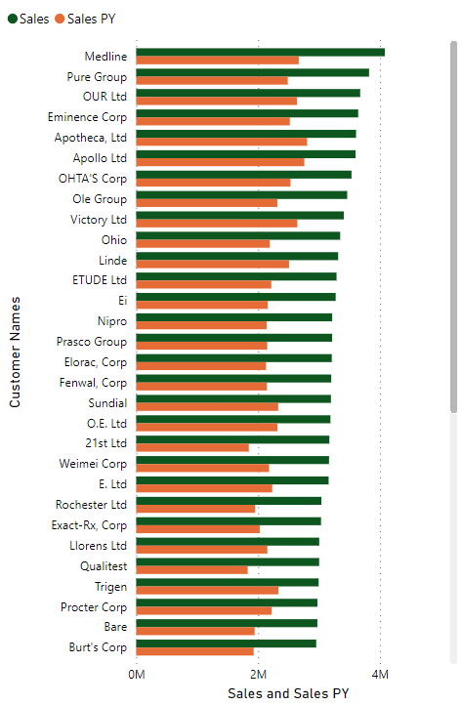

The following conclusions can be derived from the above visualization:

* At 4M, Medline had the highest Sales and was 72.58% higher than WakeFern, which had the lowest Sales at 2.4M.﻿
* ﻿Medline accounted for 2.64% of Sales.﻿
* Sales and total Sales PY are positively correlated with each other.
* Current Years Sales increased the most than Previous Year Sales PY when the Customer Names was Medline. The difference was 1.4M.﻿
* There are 0 customers where the Sales PY are higher than Sales this year.
* The least increase in Sales from the Previous Year was for the Customer 3Lab, Ltd.

**Issues Identified:**

* Sales of Products 6,8,14,10,12,3 and, 4 are very low across every year.
* Many cities which have less than 1% share in the sales.
* December 2019 produced a significant decrease in Sales.
* Wholesale products account for 53% of the profits, so there is a need to focus more on the Distributor and Export.
* There is a need to focus on the Customer 3Lab, Ltd as they have produced the least increase in sales from the previous year.

**KPIs:**

1. Sales, Profit, Profit Margin and Products Sold

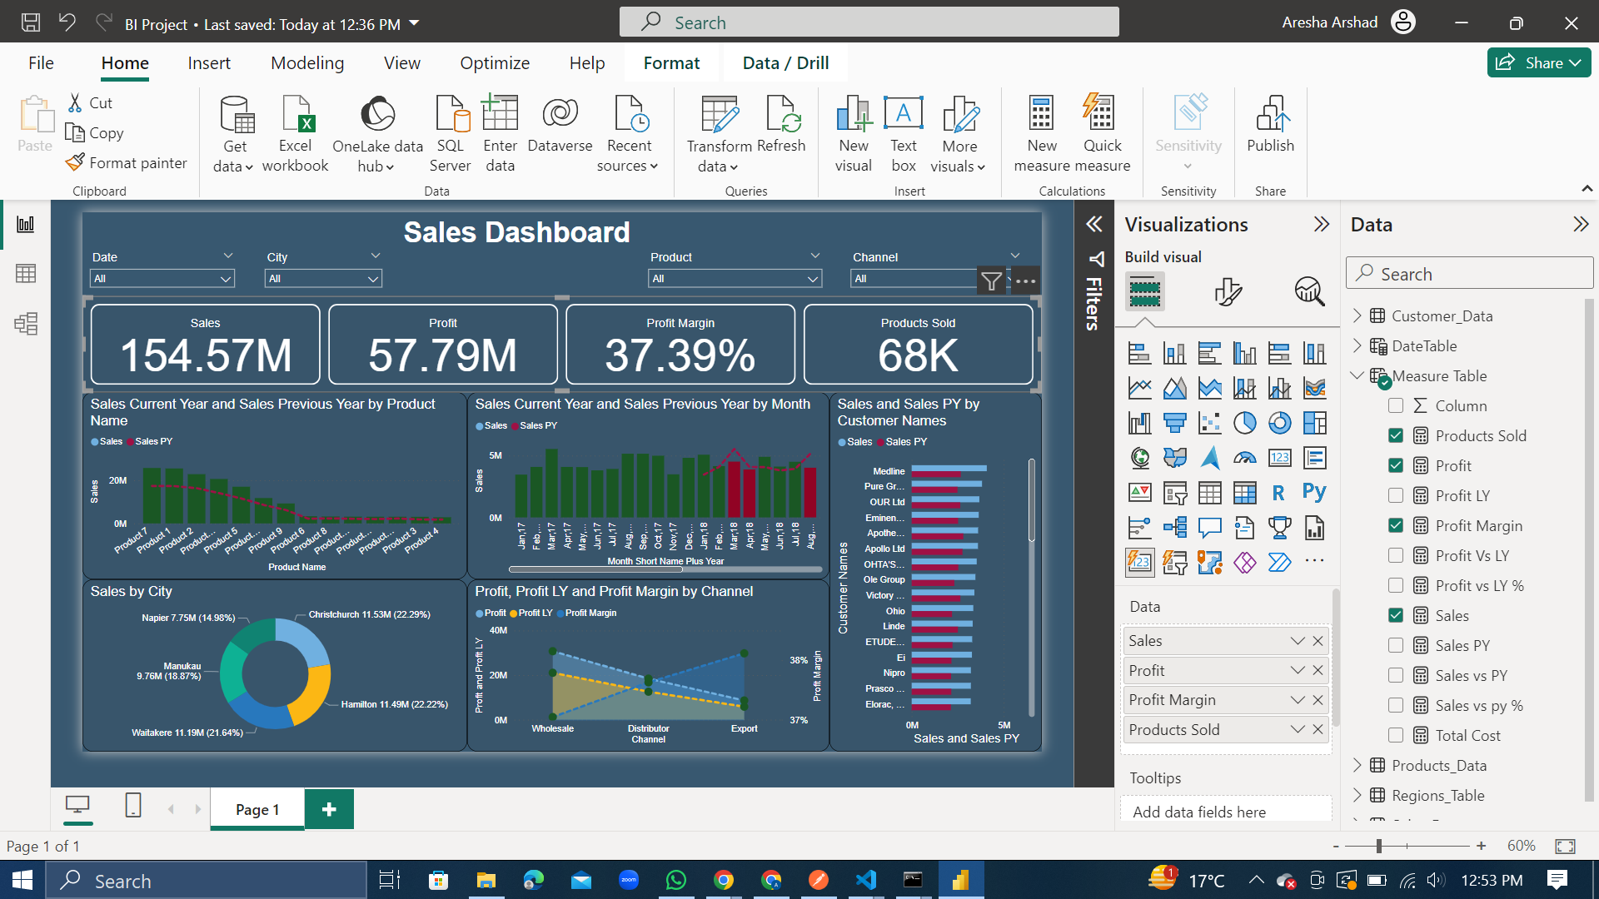

1. Sales vs PY %, Profit vs LY %

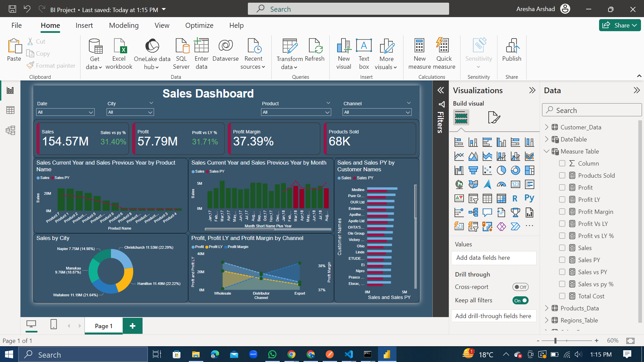

The Sales vs PY % and the Profit vs LY % are printed with green font showing that the percentage is positive, depicting an increase. Thus, we can see that there is a 31.4% increase in the sales from the previous year and there is 31.71% increase in the profit compared to last year.

**Dashboard Layout:**

The final dashboard looks like this:

